 ClaimContact Widgets

Configuration Exercise

Configure ClaimCenter to meet the following customer requirement from Acme Insurance.
(This lesson depends upon the data model modifications made in the "Contact Roles" lab.)

Requirement: Adding Interpreters Directly to Negotiations

Acme Insurance wants to be able to assign an interpreter to each negotiation.

1. Create a widget on the Negotiation Detail page that lets users assign a contact to the negotiation that inherently has the role of interpreter. The widget should meet the following criteria:
- It appears below the Negotiation Contact field.
- It is labeled "Interpreter".
- The dropdown lists only contacts that are of subtype Person.
- The picker menu allows only contacts of subtype Person to be created.

Note: If you can not see your new interpreter virtual property within Studio, restart Studio.

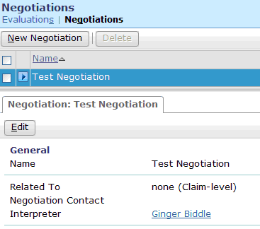

Test Case

When you have completed your configuration, run the following test cases:

2. Log on to ClaimCenter and navigate to a claim which has at least one person contact and one company contact. (If necessary, add a contact to an existing claim, such as adding an auto repair shop to an auto claim.) Verify that:
- The Interpreter widget is visible.
- The dropdown lists persons (but not companies).

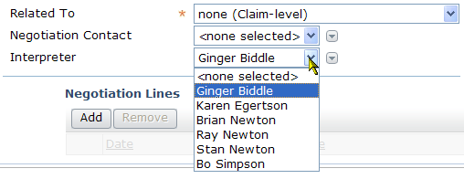

3. Create a new interpreter. Then, go to the Parties Involved screen and verify that the new interpreter is listed there with the role of interpreter.

